Resolution from North American Horizons on Albertan Independence
Introduction: We support the will of the people of Alberta to choose independence from Canada and, should they also desire, would welcome them as the 51st state in our union.
Summary: Over the past few decades, Alberta has seen a vast and continuous slice of its economic resources and might stripped away by the federal government of Canada that could have otherwise been used to serve the people of Alberta.
Whereas if Alberta were to leave the Canadian political system, it would not be subject to the same level of tariffs, quotas, or other financial, goods, or services regulations, restrictions, or government revenue laws that would be applied to the rest of Canada. As a result, there would be a significant boost in job creation and general economic growth for working and middle-class Albertans.
Whereas if Alberta were to join the United States, it would pay lower taxes and have no trade restrictions with the United States, which is the world’s largest economy, largest consumer market, and has the world’s largest, deepest, and most liquid financial market. Alberta would also not have to worry about paying for its own foreign policy, diplomacy, or security, while having unrestricted access to selling goods in the United States and access to tens of trillions in private capital.
Whereas Alberta has forked over 600 billion dollars in net contributions since 1961 to the Canadian Federal government, roughly 5% of its total economic output (Tombe, 2025). Furthermore, in 2019, Federal revenue outpaced Federal Spending in Alberta by about $5000 per capita (Tombe, 2025). This is immensely unfair to the hard-working people of Alberta. Working class and middle class Albertans deserve better.
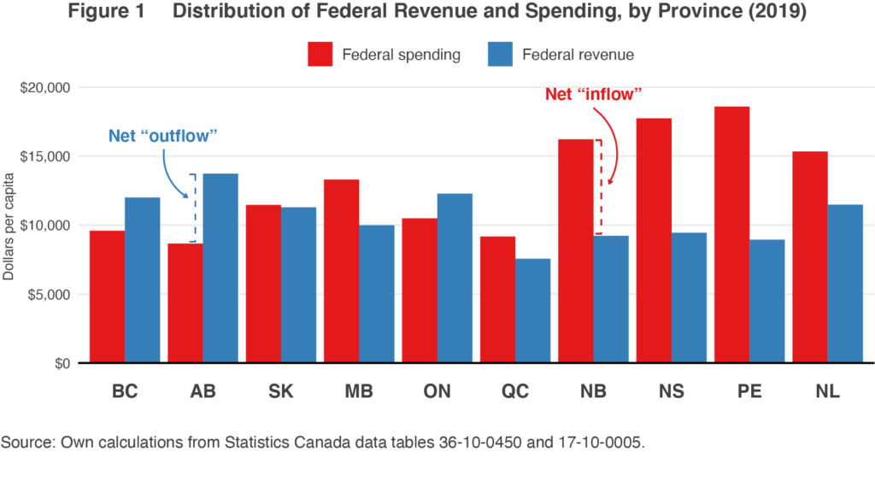
Whereas Alberta has its own unique sub-cultural and distinct identity compared to the rest of Canada, especially the maritime provinces; some claiming Alberta is the last “internal North American nation to form” (Staples, 2021). Alberta is often the target of aggressive legislation from the Canadian Federal government. (Staples, 2021)
Given the less-than auspicious history and relationship Alberta has had with the Canadian Federal Government, we propose the following to benefit the people of Alberta:
- An informative and transparent process where Albertans have access to all available information on data that would allow them to analyze the monetary benefits of staying in Canada vs being its own country vs joining the United States, without interference from the Federal Canadian government denying access to information, engaging in election interference or manipulation, or engaging in intermediation or retaliatory threats.
- That the Federal Canadian government commits to following the same fair and transparent process with the other prairie provinces.
- That the United States Congress prepares itself to rapidly accept Albertan statehood should Alberta choose to join the United States.
- That if the Canadian government doesn’t respect the rights of Alberta to choose a separate destiny and chooses to use military or equivalent force, the United States Federal government will engage in peacekeeping and humanitarian operations in support of the citizens of Alberta's right to choose, with the ability to use Department of Defense, Homeland Security, National Guard, or Private Security Contractors to engage in these peacekeeping and Humanitarian operations.
- If the Canadian government enacts a campaign of intimidation or issues threats against the people of Alberta for having a vote, that economic punishments be levied against the Federal government of Canada until they respect the right of Albertans to choose in a transparent and fair way.
Sources:
- Tombe, T. (2025, February 20). Hub explainer: Alberta’s $600-billion federal contribution leaves fairness in the eye of the beholder. The Hub Hub Explainer Albertas 600billion federal contribution leaves fairness in the eye of the beholder Comments. https://thehub.ca/2021/07/26/hub-explainer-albertas-600-billion-federal-contribution-leaves-fairness-in-the-eye-of-the-beholder/
- Tombe, T. (2021, March 3). Who “pays” and who “receives” in confederation? Finances of the Nation. https://financesofthenation.ca/2020/11/17/who-pays-and-who-receives-in-confederation/
- David Staples. (2021, Dec 08). Other Canadians don’t much like Alberta? thank goodness | edmonton journal. (n.d.). https://edmontonjournal.com/news/politics/david-staples-other-canadians-dont-much-like-alberta-thank-goodness-for-that

